

**PROJET TITLE:**

***"SMART IRRIGATION SYSTEM’’***

**GROUP MEMBERS NAME:**

KAMRAN HYDER

ROLL NO: 24

KHIZRA NAEEM

ROLL NO: 25

HASSAN ALI

ROLL NO: 18

**SUPERVISOR NAME:**

**SIR SHEHREYAR SHAHZAD**

Table of content:

ABSTRACT:

Water management is paramount in countries with water scarcity. This also affects agriculture, as a large amount of water is dedicated to that use. The possible consequences of global warming lead to the consideration of creating water adaptation measures to ensure the availability of water for food production and consumption. Thus, studies aimed at saving water usage in the irrigation process have increased over the years. Typical commercial sensors for agriculture irrigation systems are very expensive, making it impossible for smaller farmers to implement this type of system. However, manufacturers are currently offering low-cost sensors that can be connected to nodes to implement affordable systems for irrigation management and agriculture monitoring. Due to the recent advances in IoT and WSN technologies that can be applied in the development of these systems, we present a survey aimed at summarizing the current state of the art regarding smart irrigation systems. We determine the parameters that are monitored in irrigation systems regarding water quantity and quality, soil characteristics and weather conditions. We provide an overview of the most utilized nodes and wireless technologies. Lastly, we will discuss the challenges and the best practices for the implementation of sensor-based irrigation systems.

**PROBLEM STATEMENT ISSUES:**

Irrigation of plants is usually a very time- consuming activity, to be done in a reasonable amount of time, it requires a large amount of human resources.

Traditionally all the steps were executed by humans. Nowadays some systems use technology to reduce the number or workers or the time required to water the plants. With such systems, the control is very limited, and many resources are still wasted. The contemporary perception of water is that of a free renewable resource that can be used in abundance. It is therefore reasonable to assume that it will soon become a very expensive resource everywhere. In addition to the excess cost of water labor is becoming more and more expensive. As a result, if no effort is invested in optimizing these resources, there will be more money involved in the same process.

**PROBLEM SOLUTION:**

We have made Automatic Plant Watering System Using Arduino UNO. In this system, soil moisture sensor senses the moisture level of the soil. If soil will get dry, then sensor senses low moisture level and automatically switches on the water pump to supply water to the plant. Technology is probably a solution to reduce costs and prevent loss of resource, this project can be a strong way to tackle such a situation.

* **PROJET TITLE:**

**SMART IRRIGATION SYSTEM USING ARDUINO.**

* **DESCRIPTION:**

Smart irrigation system is a prototype of a system of irrigation or watering automatically based on a Arduino microcontroller integrated with proximity Sensors (soil moisture sensor), NodeMCU-ESP8655, Servo motor and the mini water pump.

* **REQUIREMENT (SOFTWARE):**
* ARDUINO IDE (INTEGTRATED DEVELOPMENT ENVIROMENT)

Circuit diagram:

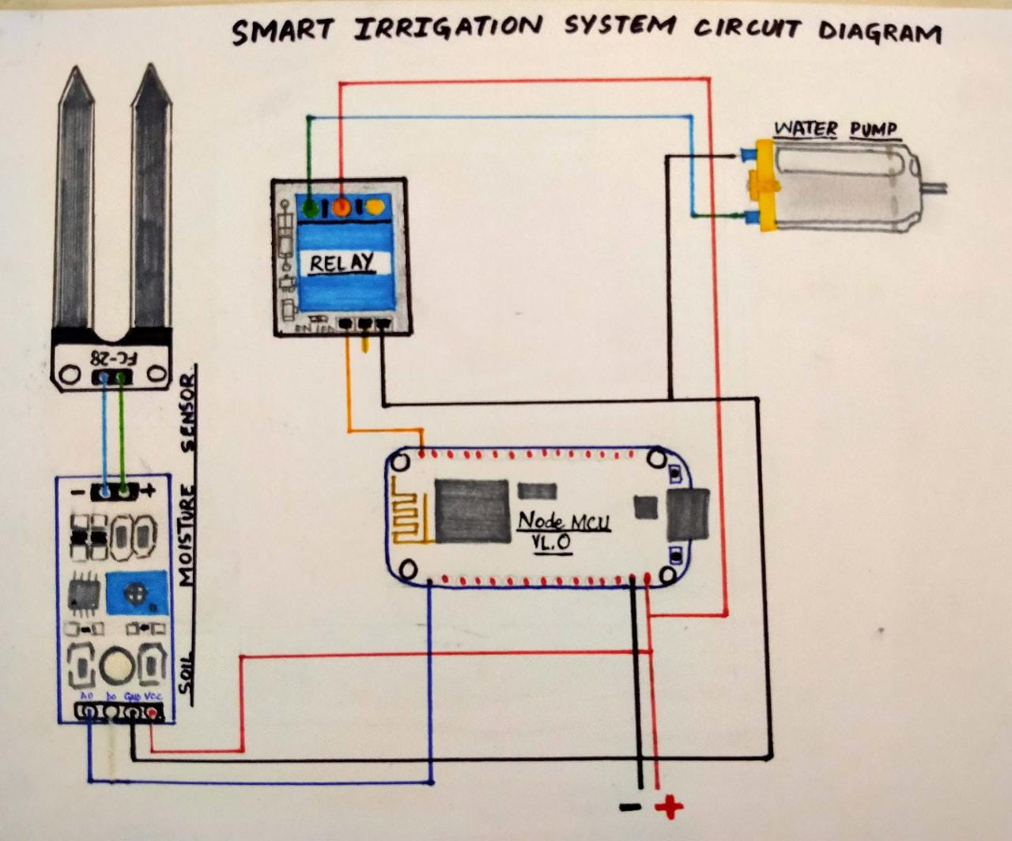

**For programming the ESP8266 NodeMCU module is used as external library. The moisture sensor gives analog output which can be read through the ESP8266 NodeMCU analog pin A0. Since the NodeMCU cannot give output voltage greater than 3.3V from its GPIO so we are using a relay module to drive the 5V motor pump. Also the Moisture sensor is powered from external 5V power supply.**

**COMPONENTS:**

* NodeMCU-ESP8655
* Server motor
* Soil Moisture Sensor
* Mini Water Pump
* Jumper Wires
* Relay module
* Breadboard

**TARGET AREA:**

Smart irrigation system using this is a very popular project nowadays. if you are searching for the project you are in the right place. you will learn a lot of things in this article regarding smart irrigation system. it is actually a precision automatic watering system for the plant which automatically watering the plant without your engagement with the system. this is made up which can easily make by the nontechnical persons also so it is the  **irrigation system** this system is using in gardens and farms widely. So many of the students searching this project over the internet. the smart irrigation system is not using only the garden and farms it is implementing into the crops and smart greenhouse also.

**WORKING:**

As we are using a soil moisture sensor that senses the moisture content in the soil and send this data to the Arduino that we are using. Soil moisture sensors can send data in both. in analog as well as in digital. so we are using the analog data here to get the accuracy in the project. we insert the soil moisture sensor in the soil and connected it to the Arduino and the sensor sends the data to the Arduino about the moisture inside the soil. then the Arduino will get the action on the data. according to the condition given in the program. if the soil moisture sensor detects no moisture or very less moisture then the pump will get started and watering the plants.

I would like to mention too that this is an advanced version of the smart irrigation system which recognize the less moisture contain soil into the various field. in this project, the water pipe is connected to the servo motor which rotates according to the requirement. if there are two crops A & B. and if A having less amount of moisture then the servo motor rotates toward the crop A. and starts the watering and when it will fill up it will rotate towards the crop B.

The Smart irrigation System has wide scope to automate the complete irrigation system. Here we are building a IoT based Irrigation System using ESP8266 NodeMCU Module. It will not only automatically irrigate the water based on the moisture level in the soil but also send the Data to ThingSpeak Server to keep track of the land condition. The System will consist a water pump which will be used to sprinkle water on the land depending upon the land environmental condition such as Moisture.

ADVANTAGES:

* The farmers easily use in crops and agriculture field.
* You are in complete control.
* **Irrigation systems** will increase the value of your home.
* It is cost effective, time saving and automatic.
* Save a ton of money by reducing water waste.
* Enhanced Landscape Health And Beauty.
* Helps you prepare for the future of water.
* Smart irrigation controllers help you reduce hardscape loss.
* Avoid fines with your smart irrigation controller.

DISADVANTAGES:

1. Excessive seepage and leakage of water forms marshes and ponds all along the channels. The marshes and the ponds in course of time become the colonies of the mosquito, which gives rise to a disease like malaria.

2. Excessive seepage into the ground raises the water-table and this in turn completely saturates the crop root-zone. It causes waterlogging of that area.

3. It lowers the temperature and makes the locality damp due to the presence of irrigation water.

4. Under irrigation canal system valuable residential and industrial land is lost.

5. Initial cost of irrigation project is very high and thereby the cultivators have to pay more taxes in the form of levy.

**Conclusion:**

The microcontroller based drip irrigation system proves to be a real time feedback control system which monitors and controls all the activities of drip irrigation system efficiently. The present proposal is a model to modernize the agriculture industries at a mass scale with optimum expenditure. Using this system, one can save manpower, water to improve production and ultimately profit. This paper involves establishing a contemporary design technique of monitoring and controlling the moisture level of soil using Lab VIEW. Providing comprehensive tools that need to build any measurement or control application in dramatically less time. The project also includes rain sensor, which is very important in the project to avoid unnecessary power wastage. No longer only are farmers able to generally use much less water to grow a crop, they're able to increase growth yields and the satisfactory of the crop by using better management of soil moisture at some point of vital plant growth degrees. Embedded system for computerized irrigation of an agriculture subject gives an able solution to assist web page- precise irrigation control that permits producers to maximize their productivity whilst saving the water.